How Can I Revoke A Seat In My Organization?

在我团队里如何撤销Seat呢?

**Symptoms**

* I would like to revoke seat of my license
* 我想要撤销在我许可里的Seat
* A member of my Organization has left and I would like to reclaim the license (seat) they were using
* 我团队里的成员退出后我想收回他们正在使用的许可证（seat）

**Cause**

You need to be the Owner Manager of an Organization to manage seats.

团队所有者的管理员可以管理seats。

You may wish to transfer the seat to a new user. This may be needed if, for example, a user leaves your Organization and you wish to give the seat to a different member of your Team, or a new Contractor.

您可能希望将seat转移给新的用户。如果用户离开您的团队并且您希望将作为交给团队的不同成员或新的承包商，则可能需要这样做。

**Resolution**

For licenses that were purchased before 28th June 2016, please see this [article](https://support.unity3d.com/hc/en-us/articles/205056069).

在2016年6月28日之前的许可证，请参考本文

To reassign the license to a new user, you can revoke the 'seat,' in your Organization. To do this, follow these steps:

要将许可证重新分配给新用户，您可以撤销团队中的“seat”。为此，请按照以下步骤操作:

* First sign in to your Unity account on the main [site](https://id.unity.com/account/edit). On the left hand side of the screen you will see the 'Organizations' Tab.
* 首先在主页上登录您的Unity账户。在屏幕的左侧，您会看到“Organizations”的选项。

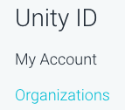

This will show the Organizations you own, or are a member of.

这将显示您拥有的组织，或是显示是哪些组织的成员。

* Click the 'Manage/View' button on the right side of the Organization you wish to return a seat on. Please note you may only return a seat for a Organization if you are the Owner or Manager.
* 点击组织右侧的'Manage/View'按钮显示您希望返回的seat。请注意您只可以返回您是所有者或者管理者的seat。



* On the next page, on the left side you will be able to select the option 'Seats & Services'
* 在下一个的页面，您可以在左侧选择'Seats & Services'选项

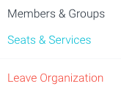

* On the following page, you will be able to see how many Seats are 'Available/Pending' in that specific Organization, then click the 'Manage Seats' button.
* 在下一个页面，点击'Manage Seats'按钮，您会看到在指定的组织中有多少个Seats是'Available/Pending'状态的。

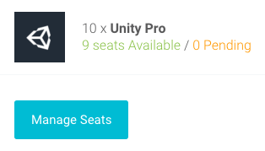

* On the next page, you will be able to remove seats from Members of your Organization. You will need to search for the Member you wish to return the license for, then click the 'cross' marked with an 'X' to the right of their name.
* 在下一个页面，您会看到在您团队成员中将要移除的seats。搜索您希望退回许可证的成员，然后点击在名称右侧标有“X”的标记。

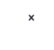 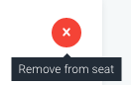

Clicking the 'cross' will free the seat so it can be used for a other/new member of your Organization.

点击“X”释放seat以便将他勇于团队中其他/新成员

**More Information**

If you want to return activations on a license in use, please see this [article](https://support.unity3d.com/hc/en-us/articles/205056069).

如果您想反激活许可证，请参考此文章。